
ATAR Biology

Unit 1: Topic 2
Week 7 – Food Chains, Webs & Pyramids

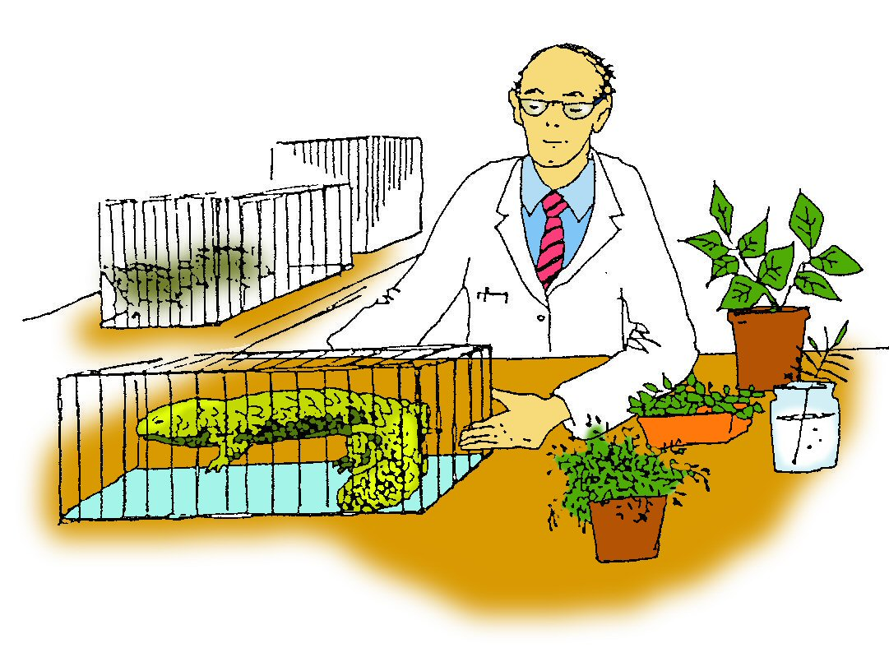

Student Study Notes

Unit Content
- The biotic components of an ecosystem transfer and transform energy, originating primarily from the sun and matter to produce biomass; these interactions can be represented using food webs and biomass pyramids.
- Select, construct and use appropriate representations, including classification keys, food webs and biomass pyramids, to communicate conceptual understanding, solve problems

Roles within a community

Organisms have certain roles within the community.

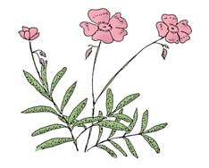
Producers
Producers, also called autotrophs, include green plants. The green pigment, chlorophyll, enables plants to trap energy from the sun. The light energy is used to combine carbon dioxide and water to produce glucose and oxygen. Glucose provides the plant with energy for growth, repair and cell activity. Glucose can also be stored as starch.
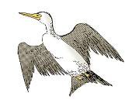
Consumers
Consumer organisms, also called heterotrophs, take in nutrients originally produced by plants. The food provides the organism with energy for growth, maintenance and activity.

Decomposers
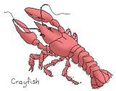
Decomposers include the saprophytic fungi and microscopic bacteria which break down the dead plant and animal material and return it to the soil as nutrients. Detritivores, such as earthworms and crayfish, are consumers of dead organic matter and animal wastes that accumulate as detritus in soil and pond mud. Most of the nutrients are returned to the community as faeces and urine, or when the consumer dies.

Decomposers

- are crucial in the cycling of nutrients within an ecosystem
- prevent the accumulation of dead plant and animal material
- are a food source for many consumers.

Energy flow in the community

Energy flows through a community. Energy from the sun is captured by plants and converted into chemical energy which is then transferred along a food chain and used by each of the organisms for growth.

At each link in a food chain, only 10 per cent of the energy is transferred from one level to the next. The rest of the energy is lost as heat or temporarily trapped in uneaten matter such as bone or fur.

Because the amount of available energy decreases as we move up a food chain, most food chains can only support four or five links.

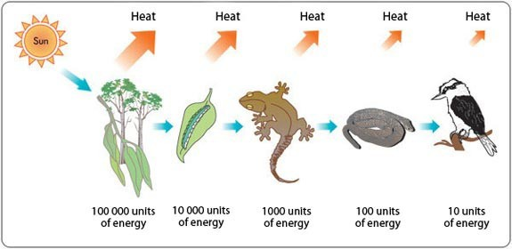

Food webs

Food chains do not usually exist in isolation. In an ecosystem, many food chains interconnect to form a food web. A food web represents the many possible feeding relationships in an ecosystem.

Food pyramids

Food pyramids show the relationships of different trophic levels in a food chain. Trophic means ‘feeding’ and each trophic level in a food pyramid is a temporary energy storage step in a food chain or food web.

There is no need to draw a 3-D shape. Pyramids can be drawn as a triangle or a stepped pyramid as shown below.

Triangle pyramid Stepped pyramid

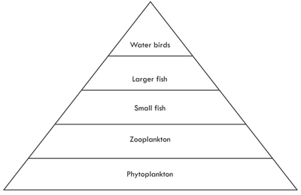
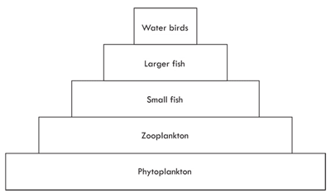

Why are trophic levels usually shown in the shape of a pyramid?

A pyramid shape is used because the transfer of matter and energy from one trophic level to the next is not very efficient. Only 10 per cent of matter and energy from one trophic level makes it to the next so each trophic level will be smaller than the previous one. A pyramid shape is a good way to represent this as shown below.

Pyramid of energy
A pyramid of energy shows the transfer of energy at each trophic level.

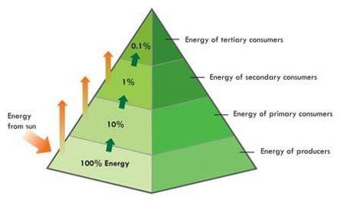

Pyramid of numbers
A pyramid of numbers shows the number of organisms at each trophic level. As you move up the pyramid the number of organisms usually decreases. A pyramid of numbers can be represented as a stepped pyramid as shown below.

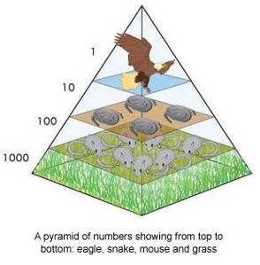

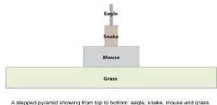

Exception to the rule
A single tree supporting many insects, birds and parasites would produce an inverted pyramid of numbers.

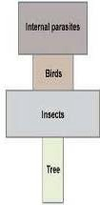

A pyramid of biomass is sometimes a better representation than a pyramid of numbers because it shows the amount of organic matter at each trophic level.

Pyramid of biomass
The biomass of an ecosystem is the total dry weight of biological material in the community. It is measured in dry weight per unit area. The biomass, of a single tree community includes the mass of the tree and would look like this:



Here is an example where the biomass is measured in kg at each trophic level.

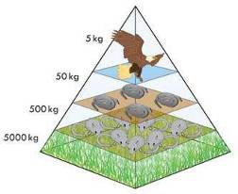

A food chain is a feeding relationship showing the transfer of energy through a chain of organisms as shown above.

1. Draw a food chain that includes a producer, a herbivore and three carnivores.

2. How many consumers are in your food chain?

3. What other biotic component should be added to your food chain?

The diagram below shows a food web in the Peel–Harvey estuary near Mandurah, south of Perth.

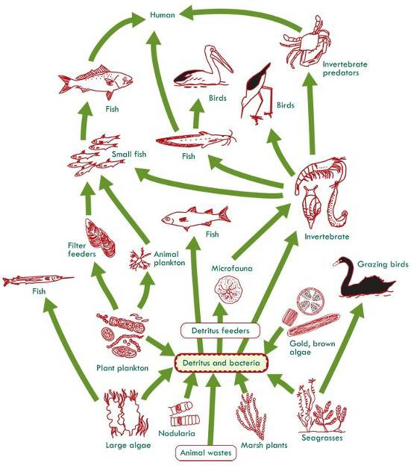

Answer the following questions based on the food web provided.

4. Name the producers.

5. Name an animal which has more than one food source and name its food source.

6. What is the advantage to the animal of utilising different food sources?

7. What role do bacteria play in the food web?

8. What is the role of detritus feeders?

Food pyramids

9. What percentage of biomass is transferred to the next trophic level?

10. Why are there only a limited number of trophic levels in a food pyramid?

11. How does a pyramid of numbers differ from a pyramid of biomass?

12. At which trophic level would you place decomposers in a pyramid of biomass?

13. In a marshland community, grasshoppers and frogs exist. Grasshoppers are herbivores and frogs feed on the grasshoppers. Which of the two populations do you expect to have more individuals and why? Hint: consider trophic levels.

Consider the food chain below.

Green vegetable seedlings Snails Bobtail Lizard Ticks

The images below show four student’s sketches of biomass pyramids for the above food chain.
Student 1 Student 2 Student 3 Student 4

14. Which student is most correct?

- Student 1
- Student 2
- Student 3
- Student 4

15. Draw a food web for the ecosystem described below.

In a particular aquatic ecosystem, tadpoles, water beetles and snails feed on freshwater algae. Frogs eat both the water beetles and the snails, and they are in turn preyed upon by kingfishers. Small fish that live in the stream feed on tadpoles. The small fish are sometimes taken by the kingfishers.

16. Name the autotroph(s) in your food web.

17. What group of organisms has not been included in your food web?

Practice Extended Response (10 marks)
“Some organisms within an ecosystem transform solar energy into chemical energy. Other species uptake the chemical energy and use it for their benefit. All members of the ecosystem have the capacity to use chemical energy, however as energy is used or it is transferred from one organism to another, energy losses occur.”

Explain each of the following:
- Transforming of solar energy into chemical energy.
- Uptake and transfer of chemical energy.
- Uses of chemical energy.
- Losses of energy.

Productivity

Productivity is the rate at which biomass accumulates or energy is stored in an ecosystem. The amount of biomass produced per year varies between ecosystems, as shown below.

Ecosystem | Productivity (kg/m2/yr)
Rainforest | 2.0
Woodland | 1.2
Grassland | 0.6
Desert | 0.1
Coral reef | 2.2
Open ocean | 0.1
Swamp and marsh | 1.5

The rate of productivity of autotrophs varies according growth conditions such as water availability, light intensity, nutrient availability and temperature.

Productivity activity

Answer the following questions by typing your answers in the blanks provided below.

1. Which ecosystems listed have high productivity levels and why?

2. Which ecosystems listed low productivity levels and why?

3. Two biomass pyramids for a lake community are shown below. One represents the levels recorded during winter; the other during spring.

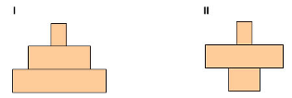

Which one represents the biomass pyramid for winter and which one represents the biomass pyramid for spring? Explain your answer in terms of productivity level.

